In February, a poster celebrating Promise students was sent to each school district around the state.
You can use this poster as a tool to make the Promise come alive in your school or district. Personalize the poster to showcase the students in your district, school or classroom by downloading this Word doc and customizing it with your own students.
You can insert a photo of your Promise student, add their quote, name, school and district/city, and then print the updated Word doc and place it on the enclosed poster.
Together, we are celebrating the accomplishments of Oregon students and working to ensure that our state’s young people have the support they need to reach their maximum potential.

“[insert student’s quote here].”
[student’s name]
[name of school]
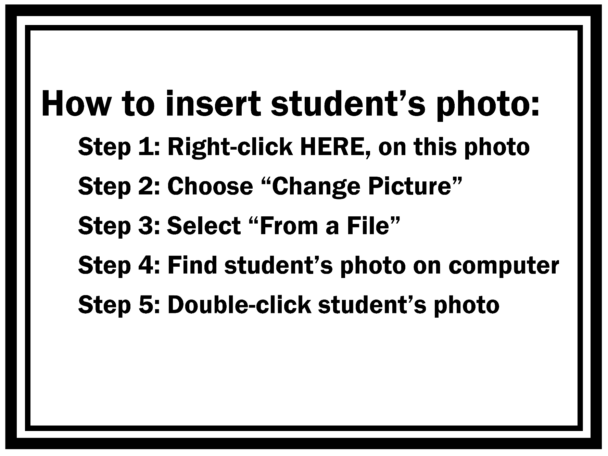
[school district or city]

